**Day 31 – Task - MongoDB Day 1**

1. Find all the information about each products
2. Find the product price which are between 400 to 800
3. Find the product price which are not between 400 to 600
4. List the four product which are greater than 500 in price
5. Find the product name and product material of each products
6. Find the product with a row id of 10
7. Find only the product name and product material
8. Find all products which contain the value of soft in product material
9. Find products which contain product color indigo and product price 492.00
10. Delete the products which product price value are 28

1) Find all the information about each products

*Products> db.products.find({});*

 

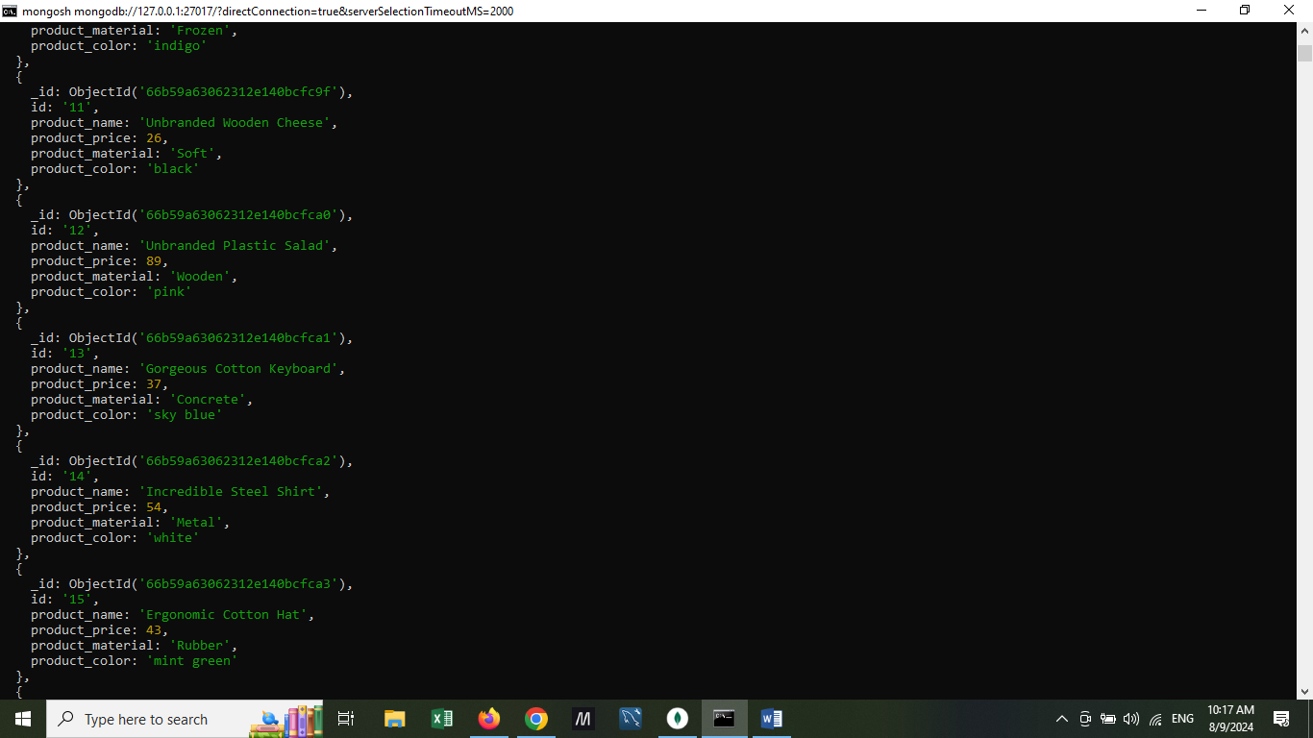 



2) Find the product price which are between 400 to 800

Ans: product price in the range [400 - 800] including 400 and 800

Query:

*db.products.find(*

*{$and :[{product_price:{$gte:400}},{product_price:{$lte:800}}]}*

*,{id:1,_id:0,product_name:1,product_price:1});*

*=>returns 5 documents:*

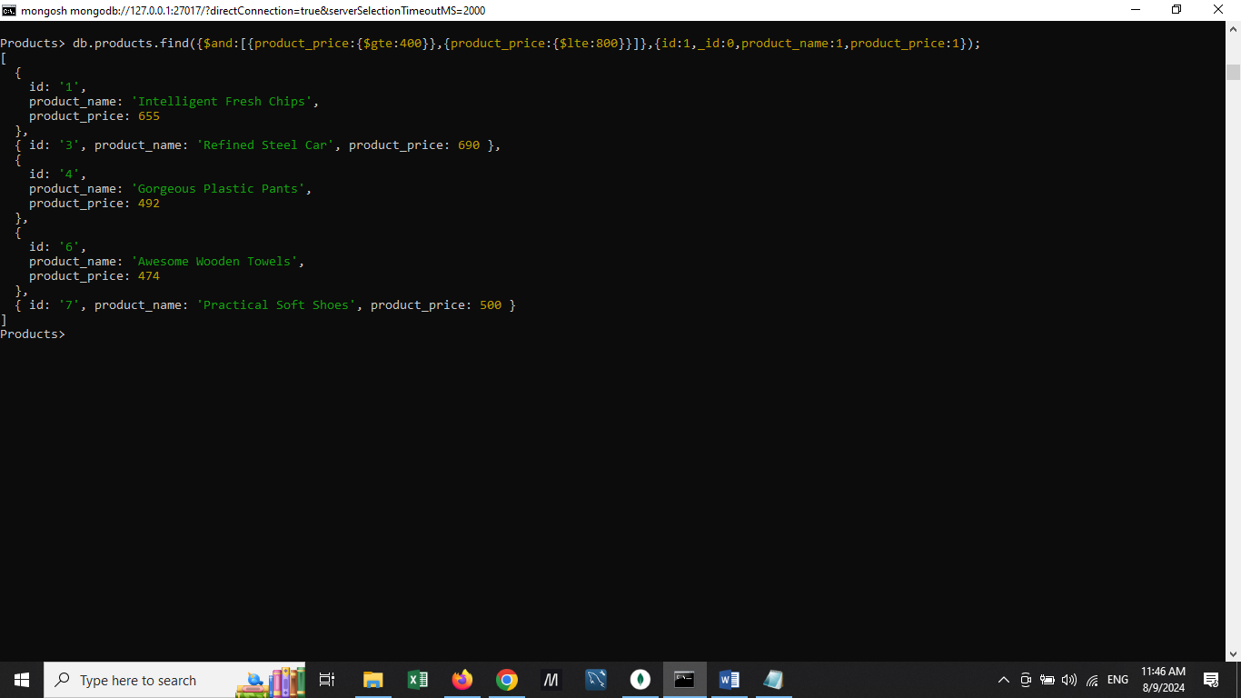

3) Find the product price which are not between 400 to 600

Ans : product price outside the range [ 400 - 600 ]inclusive

Query 1:

*db.products.find({$or :*

*[{product_price:{$lt:400}},*

*{product_price:{$gt:600}}]},*

*{id:1,_id:0,product_name:1,product_price:1});*

**Or**

Query2:

*db.products.find({product_price:*

*{$not: {$lte:600,*

*$gte: 400}}},*

*{id:1,_id:0,product_name:1,product_price:1});*

Both queries return 22 documents: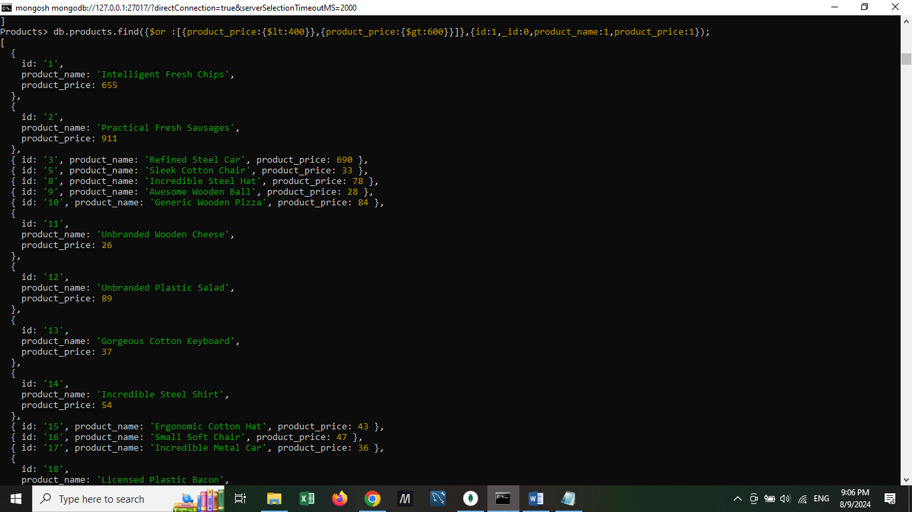 

4) List the four product which are greater than 500 in price

Ans: 1)price >500

*Products> db.products.find({product_price:{$gt:500}}).limit(4);*

Limit(4) is used to limit the result set to 4 as required in the question.



2) price >= 500

Products> *db.products.find({product_price:{$gte:500}}).limit(4);*



5) Find the product name and product material of each products

*Products> db.products.find ({}, {product_name:1, product_material:1, _id:0});*





6) Find the product with a row id of 10

*Products> db.products.find({id:"10"});*



7) Find only the product name and product material

Ans: question is same as ques 5.

*Products> db.products.find(*

*{},*

*{product_name:1,product_material:1,_id:0});*

*Assuming it’s a continuation of ques 6,*

*Query: db.products.find(*

*{id:"10"},*

*{product_name:1,product_material:1,_id:0}*

*);*

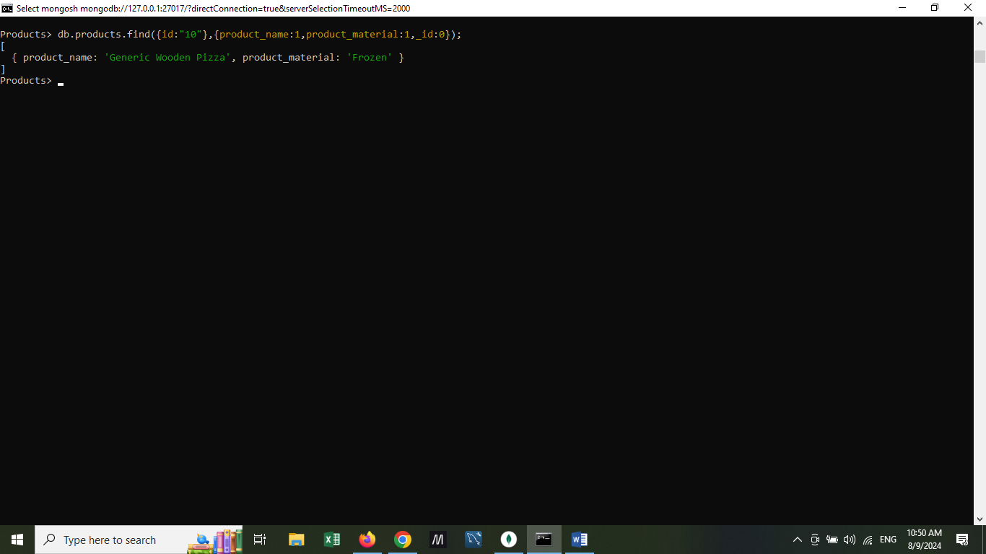

8) Find all products which contain the value of soft in product material

*db.products.find({product_material:"Soft"});*



9) Find products which contain product color indigo  and product price 492.00

*db.products.find({color:"indigo",product_price:492.00});*



10) Delete the products which product price value are 28

*db.products.deleteMany({product_price:28});*



Checking the deletion query by selecting products with price=28:

